Python file (KivyApp3.py)

-Make sure the location of the KV file is specified correctly in your computer

eg. userinterface = r"C:\Users\tscd1\PycharmProjects\KivyApp\venv\userinterface.kv"

-KV file (userinterface.kv)

Make sure the location of the SUTD Logo is specified correctly in your computer

eg. source: r'C:\Users\tscd1\PycharmProjects\KivyApp\venv\SUTD_Logo.png'

If both files is found, app should work fine.

Make sure to download necessary dependencies.

-pyrebase 4

-kivy modules

It should run like the follow below: (Below)

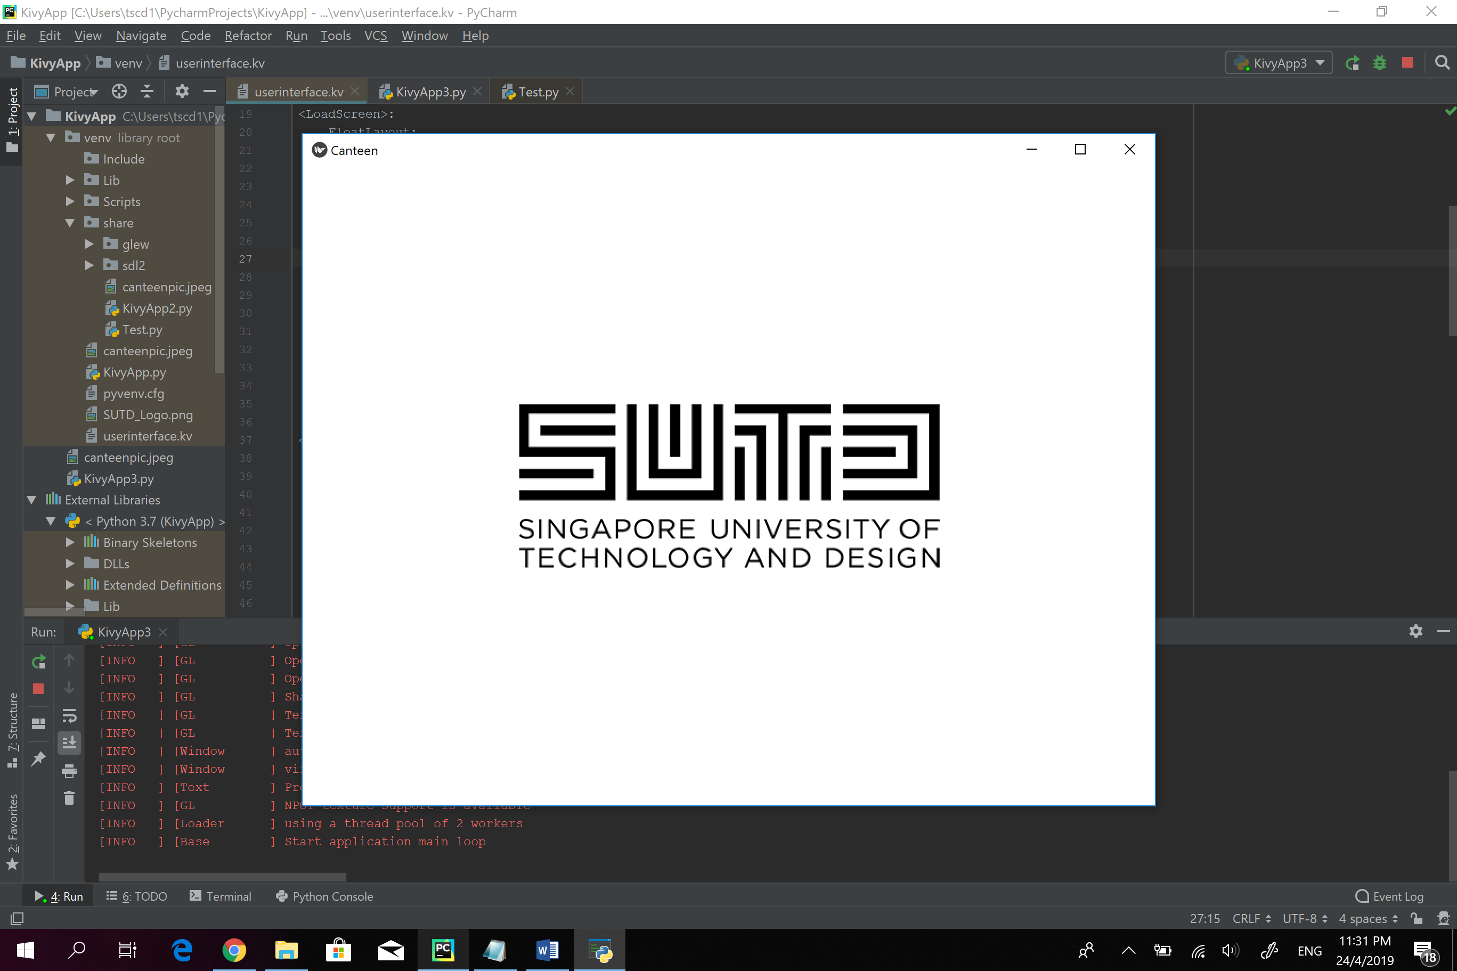

-Click once on the screen (Screen Fades)

Shows the unprocessed image from the raspberry pi camera: (Below)

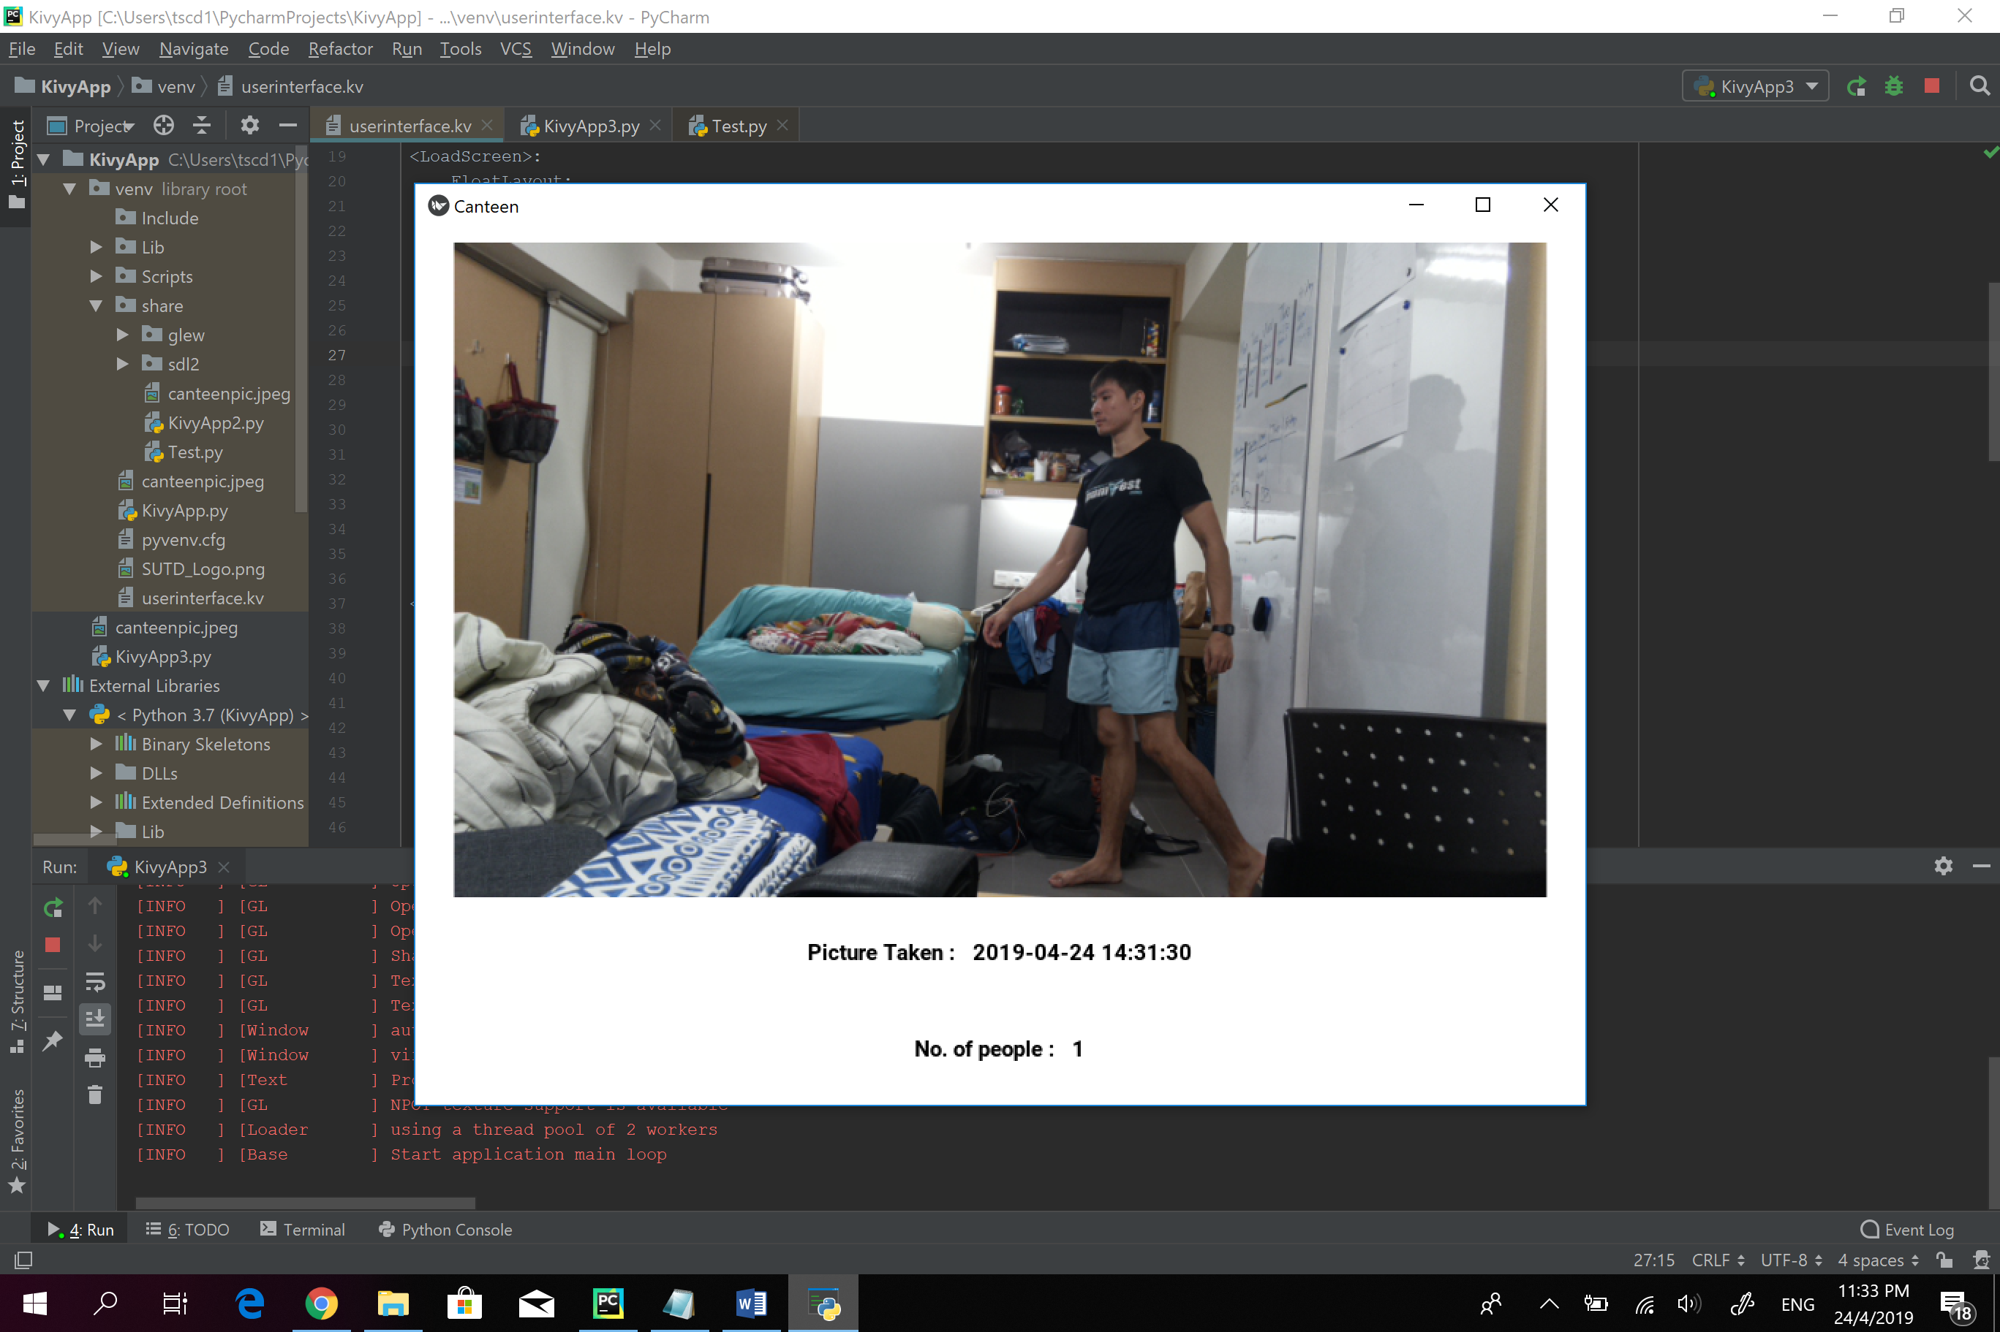

-Click once more anywhere in the app (Transitions right)

Shows the processed image: (Below)

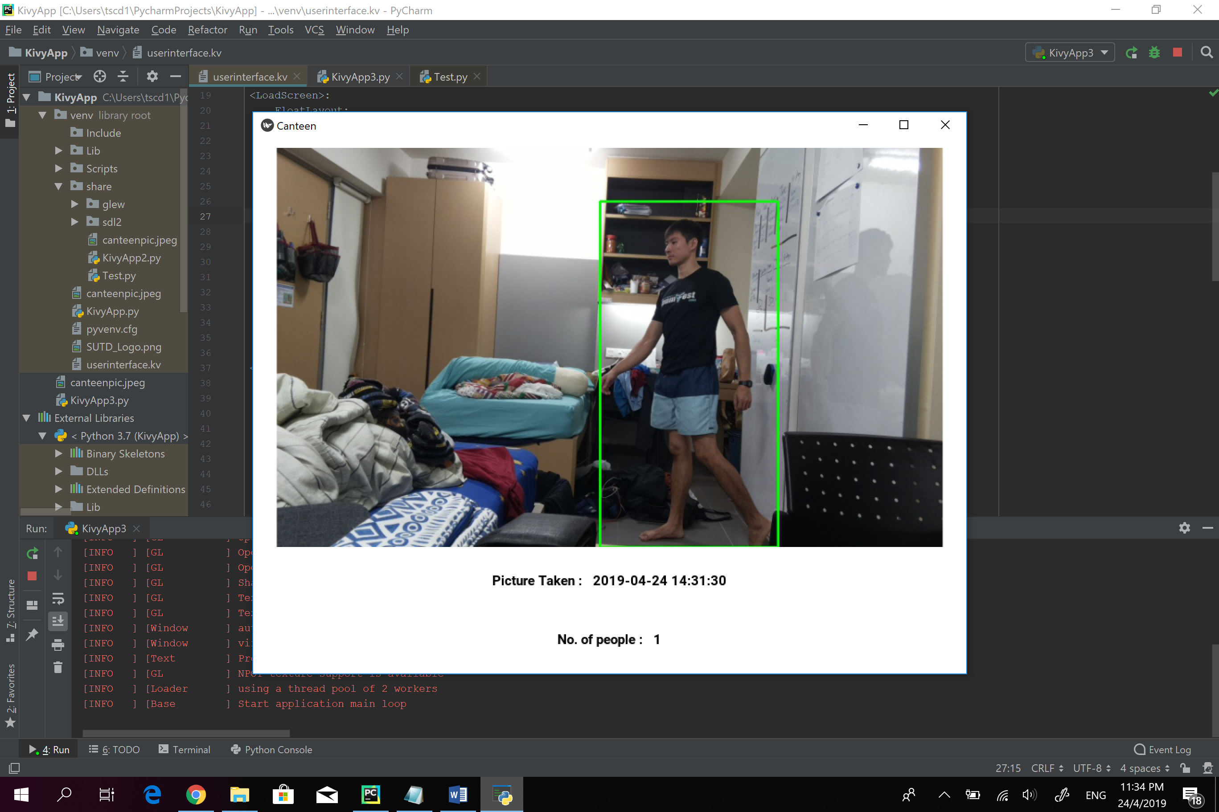

-Clicking again brings back to the unprocessed image and vice versa.